Experiment – 2.1.1
Student Name: Himanshu Goyal | UID: 24BDA70369
Branch: CSE (Data Science) | Section/Group: 24 BDS-4(B)
Course: Full Stack II (24CSP-337) | Date of Performance: 09-09-2026

1. Aim:
To design and implement RESTful APIs using Spring Boot with proper validation, standardized responses, and scalable architecture.
2. Software Required:
• Programming Language: Java (JDK 17 or higher)
• Framework: Spring Boot 3.x / 4.x (Web, Validation, Spring Data JPA)
• IDE / Editor: Visual Studio Code with Java Extension Pack / IntelliJ IDEA
• API Testing Tool: Postman / Windows PowerShell Invoke-RestMethod
• Relational Database: In-Memory H2 Database Engine / PostgreSQL
3. Objectives:
• To understand REST API design principles: stateless communication, resource-oriented URI endpoints, standard HTTP verbs.
• To implement CRUD APIs using Spring Boot: layered architecture with Controller, Service, and Repository layers.
• To enforce consistent request-response structures: encapsulating status codes, messages, and payloads in ApiResponse<T>.
• To apply validation using Bean Validation: using @NotBlank, @Size, and @NotNull annotations on request DTOs.
• To enable secure cross-origin communication: configuring CORS mappings for decoupled frontend-backend architectures.
• Course Outcomes Mapped: CO1 - BT1, CO3 - BT3
4. Theory:
REST (Representational State Transfer) is an architectural style used for designing scalable and loosely coupled web services. In RESTful systems, data is treated as resources identified by uniform resource identifiers (URIs) and accessed through standard HTTP methods such as GET (read), POST (create), PUT (update), and DELETE (remove). A well-designed API must adhere to stateless communication, meaning every request from client to server contains all necessary context for processing without server-side session reliance.
Spring Boot simplifies enterprise REST API engineering through an established layered architecture:
1. Controller Layer: Exposes HTTP endpoints, consumes request bodies, performs input binding, and returns standardized response entities.
2. Service Layer: Contains business domain logic, transactional boundaries, validation rules, and entity-DTO transformation.
3. Repository Layer: Leverages Spring Data JPA to execute database CRUD operations without boilerplate SQL.
To guarantee data integrity, Bean Validation is applied to request DTOs. Annotations such as @NotNull, @NotBlank, and @Size validate incoming payloads before reaching business logic, triggering automated 400 Bad Request responses when violated. Standardizing responses using an envelope structure (ApiResponse<T>) ensures predictable contracts for frontend clients across both successful operations and errors. Cross-Origin Resource Sharing (CORS) is explicitly configured to enable secure communication between decoupled clients and backend services.
5. Procedure / Algorithm:
• Step 1: Initialize Spring Boot project structure with Spring Web, Validation, and JPA starter dependencies.
• Step 2: Define domain model (Post) with JPA annotations (@Entity, @Table, @Id, @GeneratedValue, @Column).
• Step 3: Create PostRepository interface extending JpaRepository<Post, Long> for automated CRUD queries.
• Step 4: Implement PostService and PostServiceImpl containing business logic for create, read, update, and delete.
• Step 5: Expose RESTful endpoints under /api/v1/posts in PostController handling GET, POST, PUT, DELETE.
• Step 6: Enforce Bean Validation on CreatePostRequest and UpdatePostRequest DTOs using @Valid in controller methods.
• Step 7: Wrap all endpoints in generic ApiResponse<T> envelope returning success, message, data, and ISO-8601 timestamp.
• Step 8: Configure WebMvcConfigurer CORS bean to permit frontend origins, allowed headers, and HTTP methods.
• Step 9: Verify CRUD operations and validation failure boundaries using automated MockMvc integration tests and PowerShell.
6. Code and Output:
Listing 1: Layered Architecture – PostController REST Endpoints with Validation
@RestController
@RequestMapping("/api/v1/posts")
public class PostController {
private final PostService postService;
public PostController(PostService postService) {
this.postService = postService;
}
@PostMapping
public ResponseEntity<ApiResponse<PostResponse>> createPost(@Valid @RequestBody CreatePostRequest request) {
PostResponse response = postService.createPost(request);
return ResponseEntity.status(HttpStatus.CREATED)
.body(ApiResponse.created(response, "Post created successfully"));
}
@GetMapping("/{id}")
public ResponseEntity<ApiResponse<PostResponse>> getPostById(@PathVariable Long id) {
PostResponse response = postService.getPostById(id);
return ResponseEntity.ok(ApiResponse.ok(response));
}
@PutMapping("/{id}")
public ResponseEntity<ApiResponse<PostResponse>> updatePost(
@PathVariable Long id,
@Valid @RequestBody UpdatePostRequest request) {
PostResponse response = postService.updatePost(id, request);
return ResponseEntity.ok(ApiResponse.ok(response, "Post updated successfully"));
}
@DeleteMapping("/{id}")
public ResponseEntity<ApiResponse<Void>> deletePost(@PathVariable Long id) {
postService.deletePost(id);
return ResponseEntity.ok(ApiResponse.ok(null, "Post deleted successfully"));
}
}

Listing 2: Bean Validation DTO and Standardized Envelope (ApiResponse<T>)
public class CreatePostRequest {
@NotBlank(message = "Title is required and cannot be blank")
@Size(min = 3, max = 150, message = "Title must be between 3 and 150 characters")
private String title;
@NotBlank(message = "Content is required and cannot be blank")
@Size(min = 10, message = "Content must be at least 10 characters long")
private String content;
@NotBlank(message = "Author is required")
private String author;
// Getters, Setters, and Constructors
}
public class ApiResponse<T> {
private boolean success;
private int status;
private String message;
private T data;
private Instant timestamp;
public static <T> ApiResponse<T> ok(T data, String message) {
return new ApiResponse<>(true, 200, message, data, Instant.now());
}
public static <T> ApiResponse<T> created(T data, String message) {
return new ApiResponse<>(true, 201, message, data, Instant.now());
}
}

Listing 3: CORS Configuration for Secure Cross-Origin Frontend Integration
@Configuration
public class WebConfig implements WebMvcConfigurer {
@Override
public void addCorsMappings(CorsRegistry registry) {
registry.addMapping("/api/**")
.allowedOrigins("http://localhost:3000", "http://localhost:5173", "https://*.onrender.com")
.allowedMethods("GET", "POST", "PUT", "PATCH", "DELETE", "OPTIONS")
.allowedHeaders("*")
.exposedHeaders("X-Correlation-ID", "Authorization")
.allowCredentials(true)
.maxAge(3600);
}
}

Output 1: Create Post (201 Created) and Get All Posts with Standardized Envelope
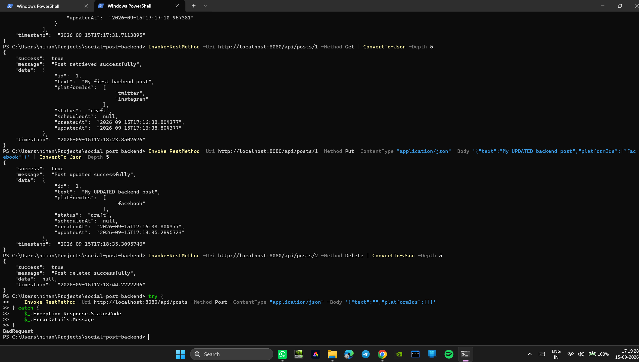
Output 2: Get One, Update, Delete, and Bean Validation Error Response (400 Bad Request)
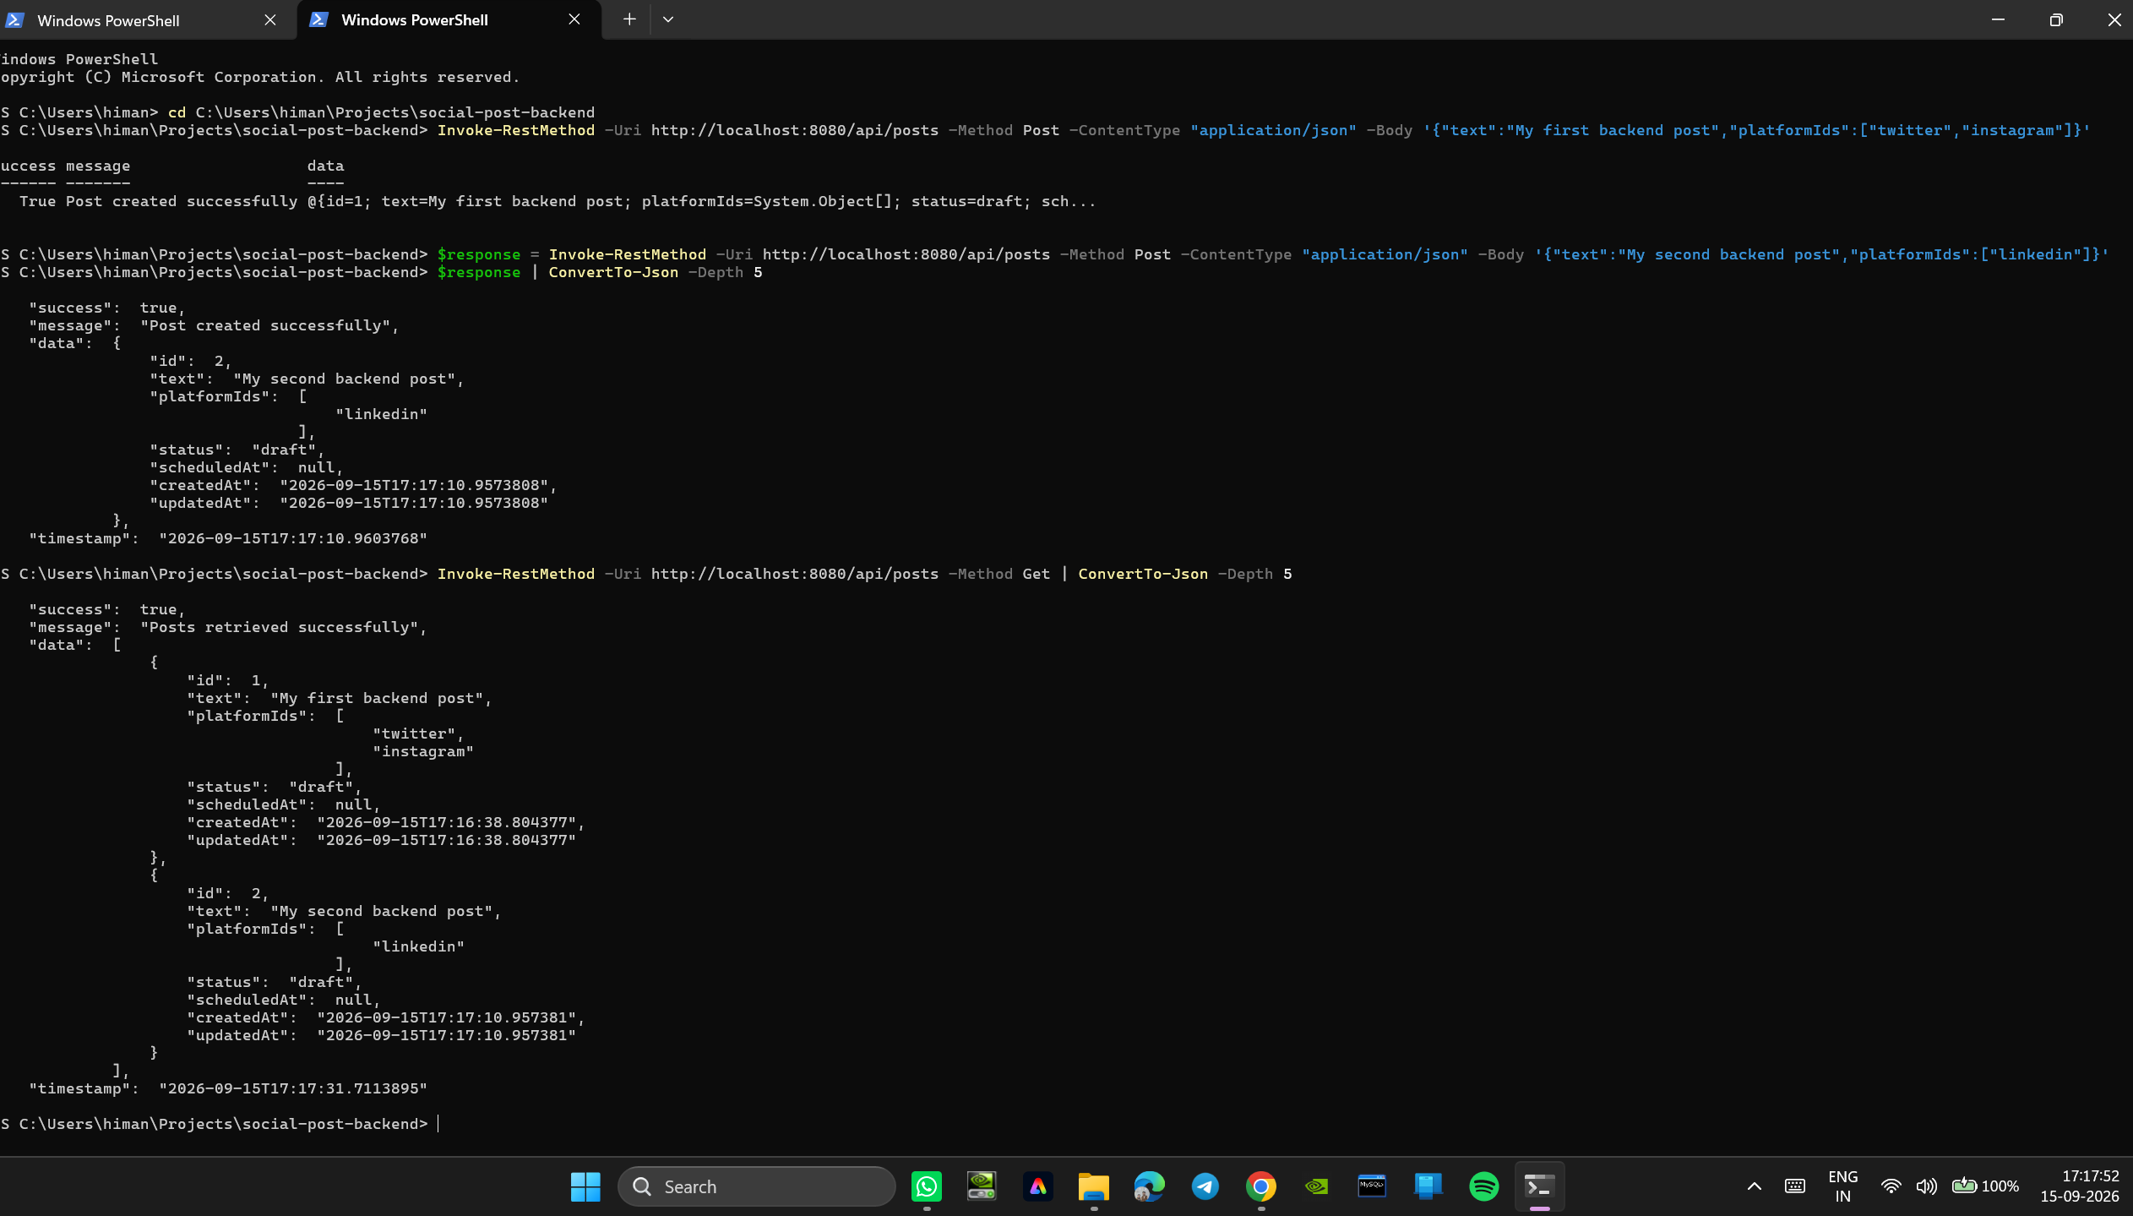
7. Conclusion:
A robust and scalable RESTful API was successfully designed, developed, and verified using Spring Boot's layered architecture (Controller-Service-Repository). All five fundamental CRUD operations (Create, Read One, Read All, Update, Delete) were implemented for the Post entity. Incoming client payloads are defensively validated using Bean Validation annotations (@NotBlank, @Size), strictly rejecting malformed data before reaching business logic. Every API response adheres to a predictable, standardized ApiResponse<T> envelope with HTTP status codes and ISO-8601 timestamps, ensuring flawless frontend contract compatibility. Secure cross-origin communication was verified through WebMvc CORS configuration, successfully meeting all architectural and design objectives.
8. Learning Outcomes:
• CO1 - BT1: Learned fundamental REST API design principles including resource URI naming, stateless HTTP communication, and standard verb semantics.
• CO3 - BT3: Applied Bean Validation constraints to enforce request data integrity before processing by business domain services.
• CO3 - BT3: Engineered standardized generic API response envelopes (ApiResponse<T>) for predictable frontend consumption.
• CO3 - BT3: Configured Cross-Origin Resource Sharing (CORS) rules to enable secure, decoupled frontend-backend communication across diverse web origins.

